**DAILY ONLINE ACTIVITIES SUMMARY**

|  |  |  |  |  |  |  |  |  |
| --- | --- | --- | --- | --- | --- | --- | --- | --- |
| **Date:** | **22/05/2020** | | | | | **Name:** | **NAIPUNYA VINOD NAIK** | |
| **Sem & Sec** | **IV SEM ‘A’ SECTION** | | | | | **USN:** | **4AL18CS050** | |
| **Online Test Summary** | | | | | | | | |
| **Subject** | | **OPERATING SYSTEMS** | | | | | | |
| **Max. Marks** | | **30** | | **Score** | | | **21** | |
| **Certification Course Summary** | | | | | | | | |
| **Course** | **JAVA PROGRAMMING** | | | | | | | |
| **Certificate Provider** | | | **GREAT LEARNING**  **ACADEMY** | | **Duration** | | | **3.5 HRS** |
| **Coding Challenges** | | | | | | | | |
| **Problem Statement:** 1)[Write a C Program to implement various operations on Singly Linked List Stack.](https://github.com/orgs/alvas-education-foundation/teams/2nd-year/discussions/77)  2) [Write a C or Java program to implement round robin type of process scheduling](https://github.com/orgs/alvas-education-foundation/teams/2nd-year/discussions/76). | | | | | | | | |
| **Status: COMPLETED** | | | | | | | | |
| **Uploaded the report in Github** | | | | | **YES** | | | |
| **If yes Repository name** | | | | | <https://github.com/naipunya-naik/lockdown-coding/blob/master/C%20CODING/stack%20sll.c>  <https://github.com/naipunya-naik/lockdown-coding/blob/master/C%20CODING/round%20robin.c> | | | |
| **Uploaded the report in slack** | | | | | **YES** | | | |

Online Test Details: (Attach the snapshot and briefly write the report for the same)

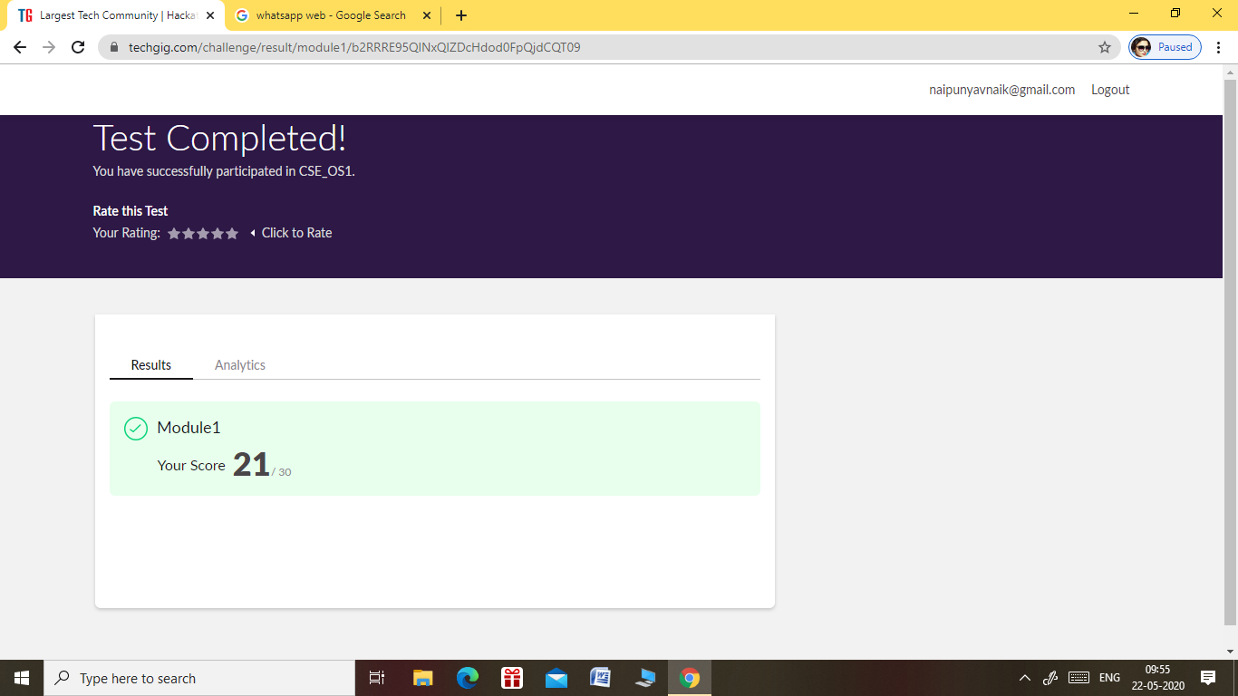

* THE 1ST I.A TEST OF SUBJECT OPERATING SYSTEMS WAS HELD ON 22 MAY 2020.
* SUBJECT NAME :- OPERATING SYSTEMS
* THE TEST DURATION WAS 40 MIN.
* START TIME:-9.15 AM
* END TIME:- 9.55AM
* TOTAL MARKS:- 30
* NO. OF QUESTIONS:- 30
* EACH QUESTION CARRIED 1 MARK

Certification Course Details: (Attach the snapshot and briefly write the report for the same)

CERTIFICATION COURSE NAME:- JAVA PROGRAMMING

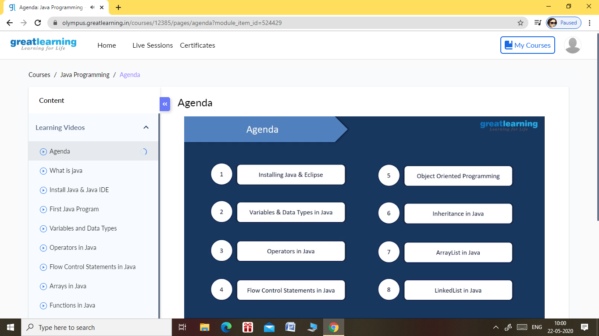

TOPICS LEARNT TODAY:-

* AGENDA
* WHAT IS JAVA
* INSTALL JAVA & JAVA IDE
* FIRST JAVA PROGRAM
* VARIABLES AND DATA TYPES
* OPERATORS IN JAVA
* FLOW CONTROL STATEMENTS IN JAVA

Coding Challenges Details: (Attach the snapshot and briefly write the report for the same)

PROBLEM STATEMENT: - [Write a C Program to implement various operations on Singly Linked List Stack.](https://github.com/orgs/alvas-education-foundation/teams/2nd-year/discussions/77)

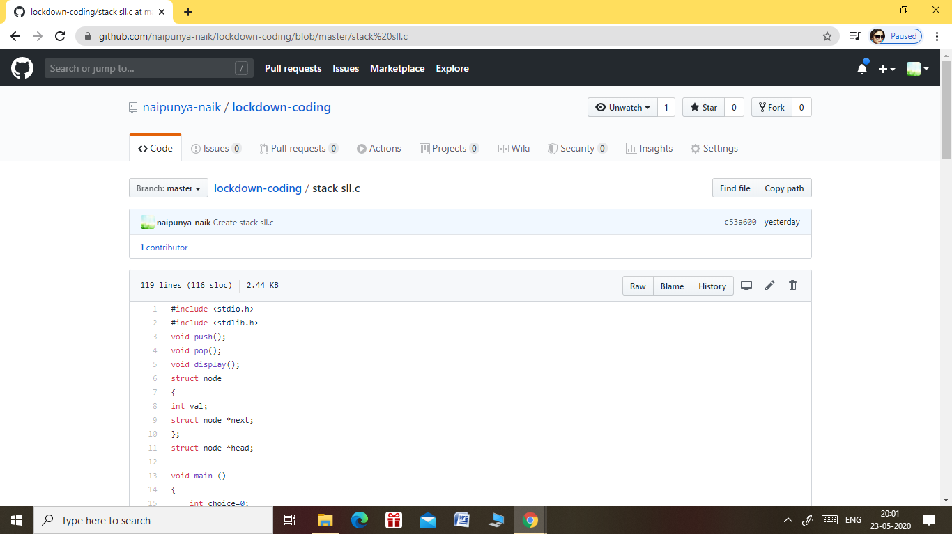

GITHUB REPOSITORY LINK:-

<https://github.com/naipunya-naik/lockdown-coding/blob/master/C%20CODING/stack%20sll.c>

PROBLEM STATEMENT 2:-

[Write a C or Java program to implement round robin type of process scheduling](https://github.com/orgs/alvas-education-foundation/teams/2nd-year/discussions/76).

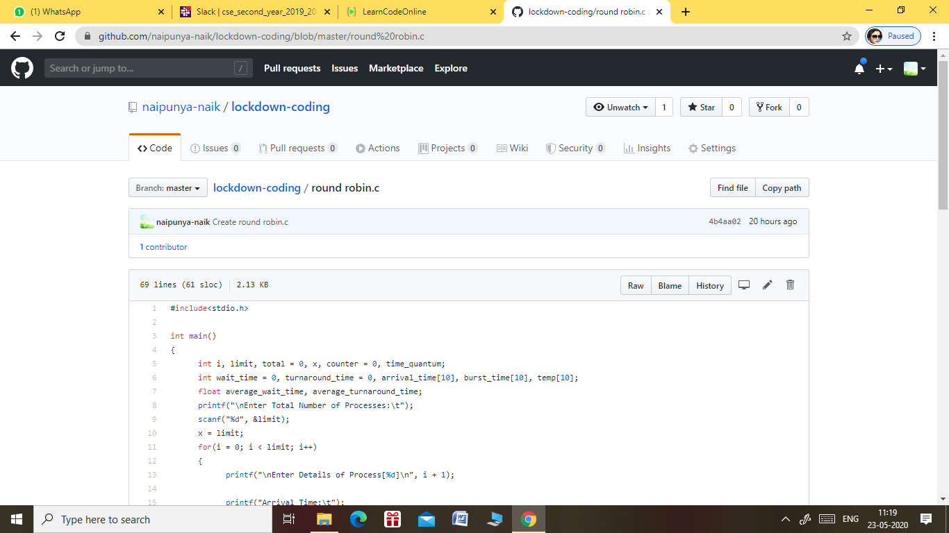

GITHUB REPOSITORY LINK:-

<https://github.com/naipunya-naik/lockdown-coding/blob/master/C%20CODING/round%20robin.c>